GPU Computing: Assignment 5 (Bonus)

*GPU used: GTX 1060 Max-Q, CUDA compute capability: 6.1 Pascal*

**Task (1)**

Successful example on a pre-stored 4x4 matrix given in the assignment. Both Device and Host produce the same results as shown.

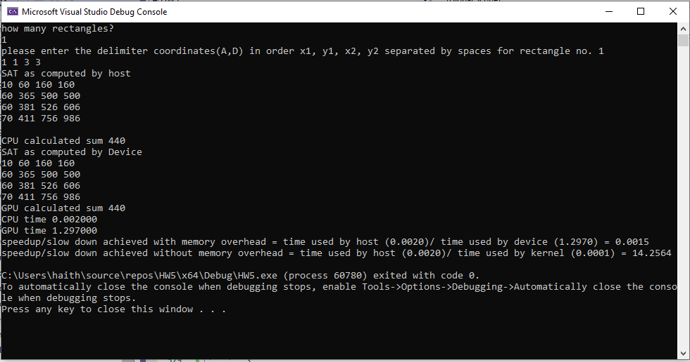

*Code segment for arbitrary image input is commented.

**Task (2)**

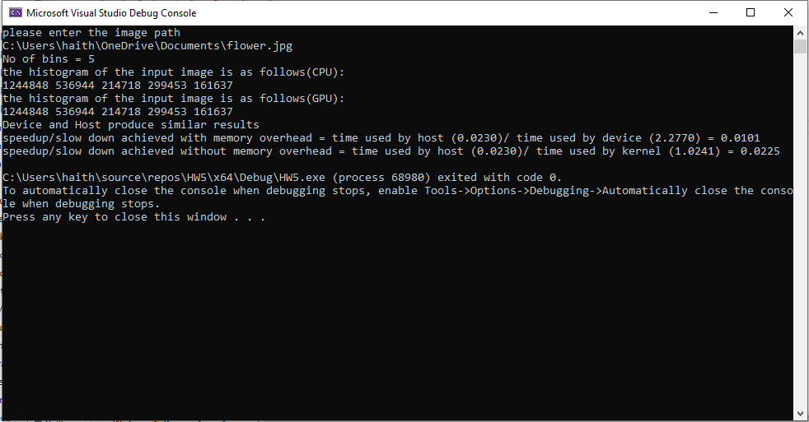

GPU and CPU produce similar results as shown for a bin size =5.

Note: Variable bin size code is commented. It works for the Host implementation, but for the kernel it needs to know the “Nbine” before runtime to allocate the shared memory needed within the kernel.